Kindergartens, Schools, planning…

Group: Jaak Vilo, Omisakin Oluwatobi Samuel, Valdur Kana, Mykhailo Dorokhov, Kenigbolo Meya Stephen, Darwin Sivalingapandi, Jevgeni Savostkin, Fortunat Mutunda

## What is the need for DATA?

* **Population Registry** - all people by precise **age** (of children)**, address,** and language (?) *It can be aggregated for privacy reasons…* (do many siblings affect the need - siblings should go to same (kindergarten/schools)
* **Kindergarten sizes and age distribution of kids currently in** - age groups/cohorts - how many admitted and will be leaving at any given time point (know the number of available places upfront)
* **Waiting list** actual status of the kindergarten (who has signed up - what address, when wants place, how many have already signed up - how many may be missing)
* **Where do kids actually go to kindergarten** now - to understand the real “waste” travel (should siblings go to same school?)
* **New building permits** - how many new families going to move in in short time from now… (match the future demand)
* Maybe some data about **playgrounds, transport,** …
* **Public aggregated data snapshots made available for planning needs**… for businesses to build more efficient services (based on better planning)

## WHY

**I Planning needs: Predict and Match - demand and supply**. Match a demand and supply 2-3 years ahead of actual time … All the time real time changes.

Observe the dynamic changes - observe or predict who moves in, where, how does that change. (Time series, make predictions on trends)

New building permits - how many flats, what type of flats being built, what is GOING TO BE a new demand.

Goal: aid the city and urban planning for Tartu. (new kindergartens, closing, places volume tuning, new teachers to be hired, etc.).

**II Teleport** like scenario: like companies could take this to the global level examples. - Where and how to move in, what are the costs and options for new people…

Family looks for a place to live, they should know number of places in kindergartens/schools available and some qualitative criteria: Estonian schools vs schools when it is possible to learn Estonian not being a native speaker. (Probably more valuable for international case)

**III SWAPPING service: Are there parents/families that might want to switch the places?** Find and propose those switches. E.g. after family moved to a new location their travel could have been made too long… And some other may be there available…

**Travel distances and SWAPPING: service School catchment areas to calculate actual travel distances to kindergartens, schools.**

Proximity to school/kindergarten. **What are other factors - e.g. workplaces affecting choice of kindergarten**? Local demand can also be higher if many people work nearby…

**Research issues** - how to ensure the privacy, differential privacy queries, etc. Play the different scenarios with models and predictions.

## Can it be hacked together at Hackathon?

Yes, it can :)

## Example of visualisations of Estonians and Russians based purely on open data - census counts per postal code and open street map…

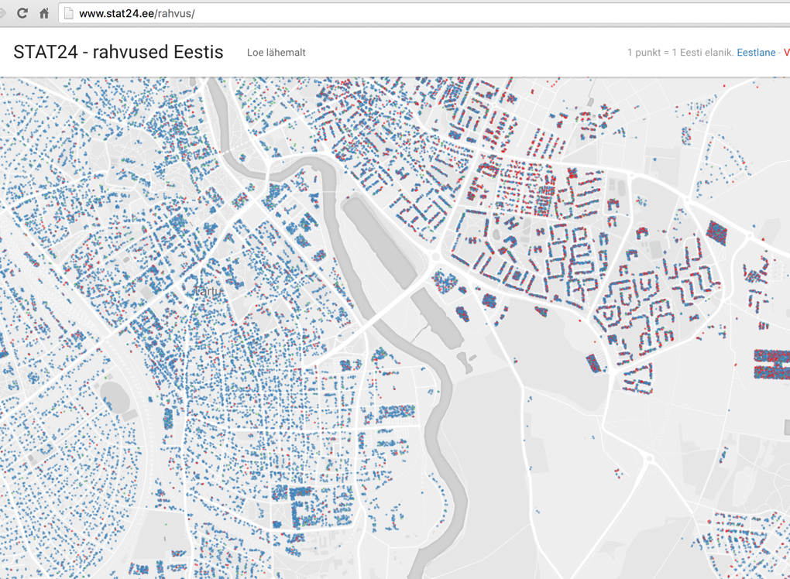

**My personal conclusions**

The report above is the final document that summarizes our discussions (barring some editing I made to the doc) however I will like to summarize and highlight some important factors about the topic.

Considering the intricate nature of the data we require, there definitely will be some issues surrounding policy and privacy. In as much as our intentions are good, having such sensitive data publicly could play into the hands of a wrong set of people (for example a paedophile interested in finding out where a large concentration of kids stay or a criminal getting to find out where the newest apartment buildings in the city are located) however as with any data made publicly available the possibility of such questions arising is quite high.

My suggestion will be the use of snapshots that will cover a specific time period. These snapshots could be monthly, quarterly or yearly and will help in comparing the trends in several situations.

Also this data can and most probably will be useful (if used and implemented via statistics) for the city council and government in budgeting as they will be able to properly plan for (if necessary) opening a new Kindergarten or school (the amount of kids to attend to etc.). It could also help marketers to know exactly where to position a business (for example, it makes sense to have an Ice cream shop close to a school or an amusement park close to where there are a large number of children).